

* **9th Alumni Newsletter - News from the University**

**Dear Alumni,**Today, you are receiving the **latest updates** from the university on the following topics:

**1. Dates for the Second Half of 2024 and the First Half of 2025**

We are once again reporting on the most important dates in the coming months. This information comes with a warm invitation for you to actively participate in these events.

We look forward to seeing you.

**University Dates**

* **Oct 24, 2024 – Feb 6, 2025, 5:00 PM - 6:45 PM:** [Early Childhood Education Evenings,](https://www.erzwiss.uni-leipzig.de/institut-fuer-paedagogik-und-didaktik-im-elementar-und-primarbereich/einrichtungen/lernwerkstaetten/werkstatt-fruehe-bildung#c322511)

University of Leipzig and ASH Berlin

* **Dec 2, 2024, 3:00 PM – 6:00 PM:** [Starting a Side Business – How Does It Actually Work?](https://ash-berlin.jobteaser.com/de/events/226928-gruenden-nebenbei-wie-geht-das-eigentlich) Founder’Center at ASH Berlin, online
* **Dec 2–6, 2024:** [Study Orientation Week – ONLINE](https://www.ash-berlin.eu/studieninfotag/), ASH Berlin
* **Jan 10, 2025, 10:00 AM – 4:00 PM:** [Doctoral and Publishing Workshop – On the Path to Article Publication,](https://ash-berlin.jobteaser.com/de/events/229677-promovieren-und-publizieren-auf-dem-weg-zur-aufsatzpublikation) DZI on behalf of ASH Berlin
* J**an 16, 2025, 12:30 PM:** New Year’s Reception at ASH Berlin, Shared Lunch in the Audimax, ASH Berlin
* **Feb 11, 2025, 2:00 PM (doors open at 1:30 PM):** [Inauguration Ceremony of the Extension Building at Alice Salomon Hochschule Berlin, Kokoschkaplatz,](https://www.ash-berlin.eu/hochschule/presse-und-newsroom/veranstaltungen/feierliche-eroeffnung-des-erweiterungsgebaeudes-der-hochschule/) ASH Berlin
* **Mar 11, 2025, 12:00 PM – 1:30 PM:** [Career Orientation in the SAGE Sector,](https://ash-berlin.jobteaser.com/de/events/229657-berufsorientierung-im-sage-bereich) Career Service, online
* **Mar 10–14, 2025, 9:00 AM – 3:00 PM:** [Career Week (various offerings from Berlin/Brandenburg)](https://ash-berlin.jobteaser.com/de/events/229706-save-the-date-career-week-berlin-brandenburg)

**Online Event Information**

In addition to the event dates listed above, you can find all event announcements on the ASH Berlin website via this [link](https://www.ash-berlin.eu/hochschule/presse-und-newsroom/veranstaltungen/). Event details will also specify whether they are digital or in-person.

**Program Dates and News**

* **Application Deadlines for Study Programs:** You and/or your employees and colleagues can apply for most study places for the summer semester 2025 (SoSe 2025) from Dec 1, 2024, to Jan 15, 2025. Exact deadlines for each program can be found [here.](https://www.ash-berlin.eu/studium/studiengaenge/)
* **New Publications:** We are pleased to introduce two new releases from ASH Berlin faculty:

**Childhood Pedagogy Handbook:** Edited by Corinna Schmude and Michael Brodowski (ed.), 2024

This book celebrates the 20th anniversary of childhood pedagogy pr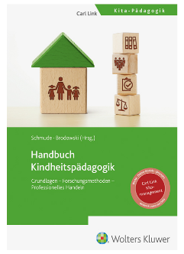ograms. It explores topics like societal and political conditions, foundational research methods, professional practices, and management of early childhood education institutions. With contributions from over 30 renowned authors nationwide, the book provides a comprehensive overview of all major topics in childhood pedagogy. The concluding chapters focus on future trends, emerging career fields, and innovations in the field.

**Manual Therapy, Manual Medicine, Osteopathy – Knowledge, Competence, Performance:** Written by Claudia Winkelmann, Lothar Beyer, and Petra Günther, 2024

This book targets health professionals, especially physiotherapists, occupational therapists, orthopedic specialists, trauma surgeons, and those in physical and rehabilitative medicine. 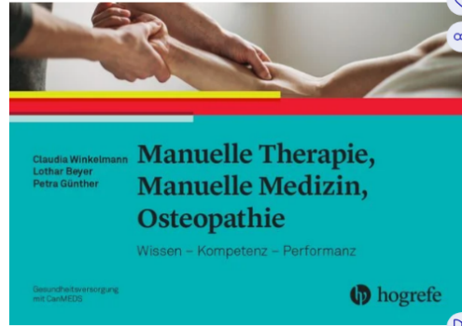The authors aim to contribute to evidence-based, standardized, and individualized manual therapy while enhancing understanding of neurophysiological, muscle-physiological, and biomechanical connections. The book emphasizes clinical expertise, professional competence, and outcome-oriented approaches, aligning with the CanMEDS framework for medical education in Germany.

**2. Programs in Focus**

In every newsletter, we will introduce two Master's programs in detail. Feel free to contact the program coordinators for further information or advice.

* **Master of Social Work: Clinical Social Work (M.A.)**

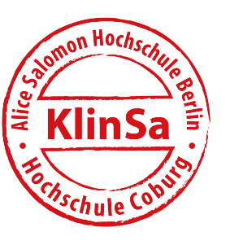This continuing education Master's program is designed for professionals in advisory, supervisory, and leadership roles across various fields of social work. It is conducted part-time and enhances counseling and intervention skills. Students gain theoretical and practical knowledge applicable to social clinical tasks during their studies, which are supported by integrated case reflection and supervision.

The program is conducted equally at ASH Berlin and Coburg University over five semesters, with the sixth semester dedicated to the Master's thesis. The program is taught in German.

For more information, visit [www.ash-berlin.eu/klinsa](https://www.ash-berlin.eu/klinsa) or [www.hs-coburg.de/klinsa](https://www.hs-coburg.de/klinsa).  
For inquiries, contact Kristiane Jornitz at [jornitz@ash-berlin.eu](mailto:jornitz@ash-berlin.eu).

* **Master of Public Health (MScPH)**

This program, offered by the Berlin School of Public Health (a collaboration of ASH Berlin, Charité, and TU Berlin), focuses on the conditions for health and coping with disease within natural, technical, and social environments.

A Master’s degree in Public Health qualifies graduates for roles in health research, administration, and management of care facilities and organizations. The program is mostly taught in German, with a few modules in English. The standard duration is four semesters.

For more details, visit the [program website.](https://www.ash-berlin.eu/studium/studiengaenge/master-public-health/profil/)

**3. Staying Connected – 2nd Alumni Day at ASH Berlin**

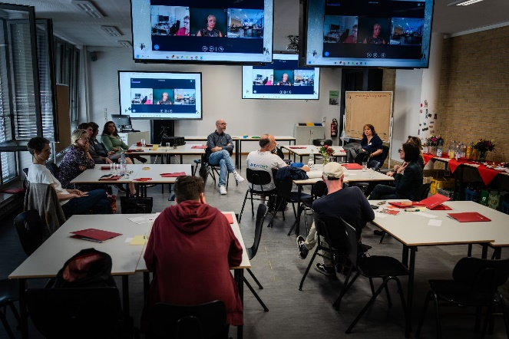

In the June 2024 newsletter, we announced that we would provide a detailed report on the 2nd Alumni Day, held on June 20, 2024, on the ASH Berlin website. The documentation and photographic impressions are now available [here](https://www.ash-berlin.eu/hochschule/vernetzung/alumni-netzwerk/2-alumnitag/).

We thank everyone who participated and appreciate the positive feedback. A special thanks to Mr. [Marjio Zupanovic](https://www.physioup.de/impressum-und-datenschutz/) for sharing his experiences with us.

**4. Are You an ASH Berlin Alumnus/Alumna and Artist?**

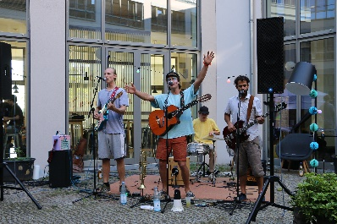We are looking for alumni of the university who are active in the arts. All forms of artistic expression are warmly welcomed. Perhaps you would like to enrich one of our future events, such as Alumni Day, with your artistic contribution? If yes, please let us know at [alumni@ash-berlin.eu](mailto:alumni@ash-berlin.eu).

**5. Alumni Moodle Platform at ASH Berlin**

We have created a Moodle platform on the topic of “+Alumni at ASH+” and warmly invite you to communicate in this virtual space. This allows you to directly influence the development of the alumni network with your expertise, ideas, and interests. We hope this is in your interest. Faculty and service staff from the university can also participate upon request.

Moodle is a learning and communication platform that provides and utilizes information such as texts, images, videos, and statistics electronically, independent of time and place. It also facilitates contact between users, enabling the exchange of ideas.

Currently, 24 alumni are participating in information exchange on this platform. Would you like to contribute? Then simply register at alumni@ash-berlin.eu. We will inform you about the next steps and are happy to answer any questions.

As a member of this platform, you are also invited to participate in the regular alumni networking meetings of ASH Berlin. Invitations are sent through the Moodle alumni platform.

**6. Career Service Offers**

The diverse range of services offered by ASH Berlin's Career Service includes free access to [job boards](https://connect.jobteaser.com/?client_id=e500827d-07fc-4766-97b4-4f960a2835e7&entity_cc_name=Career+Center&entity_color=%23e42219&entity_logo=https%3A%2F%2Fd1guu6n8gz71j.cloudfront.net%2Fsystem%2Fasset%2Flogos%2F2033011%2Flogo.png%3F1554372074&entity_name=ASH+Berlin&nonce=18548b8925ce17be47a9491462c64a3d&organization_domain=ash-berlin&redirect_uri=https%3A%2F%2Fwww.jobteaser.com%2Fusers%2Fauth%2Fconnect%2Fcallback%3Fredirect_uri%3Dhttps%253A%252F%252Fwww.jobteaser.com%252Fusers%252Fauth%252Fconnect%252Fcallback&response_type=code&scope=openid+email+profile+groups+urn%3Aconnect%3Ajobteaser%3Acom%3Aorganization+urn%3Aconnect%3Ajobteaser%3Acom%3Aextra_attributes&state=5ef2bdab24aef7b8a1e72f8e8ccb62c8&ui_locales=de), [free events](https://connect.jobteaser.com/?client_id=e500827d-07fc-4766-97b4-4f960a2835e7&entity_cc_name=Career+Center&entity_color=%23e42219&entity_logo=https%3A%2F%2Fd1guu6n8gz71j.cloudfront.net%2Fsystem%2Fasset%2Flogos%2F2033011%2Flogo.png%3F1554372074&entity_name=ASH+Berlin&nonce=bba0b779e6ec6ff92255cd069857830b&organization_domain=ash-berlin&redirect_uri=https%3A%2F%2Fwww.jobteaser.com%2Fusers%2Fauth%2Fconnect%2Fcallback%3Fredirect_uri%3Dhttps%253A%252F%252Fwww.jobteaser.com%252Fusers%252Fauth%252Fconnect%252Fcallback&response_type=code&scope=openid+email+profile+groups+urn%3Aconnect%3Ajobteaser%3Acom%3Aorganization+urn%3Aconnect%3Ajobteaser%3Acom%3Aextra_attributes&state=ab04f56679a4b6b9b9b3dbc87b634203&ui_locales=de) (especially for ASH graduates!), and individual consultations and coaching sessions on applications, career entry, and (academic) career development.

The event flyer for WiSe24/25 can be found [here](https://www.ash-berlin.eu/fileadmin/Daten/Einrichtungen/Karriereplanung/Flyer/Veranstaltungsflyer_WiSe24.pdf).

**Consultation:** Are you a graduate seeking career guidance to clarify your next professional steps or a potential career change? Schedule an individual appointment with us via careerservice@ash-berlin.eu.

**Doctoral Consultation:** What is the process of obtaining a doctorate? What paths are available for students at universities of applied sciences? How can I develop a doctoral proposal? For these and other questions, schedule a consultation appointment at [promovieren@ash-berlin.eu](mailto:promovieren@ash-berlin.eu).

**Jobs & Careers:** Our [job board](https://connect.jobteaser.com/?client_id=e500827d-07fc-4766-97b4-4f960a2835e7&entity_cc_name=Career+Center&entity_color=%23e42219&entity_logo=https%3A%2F%2Fd1guu6n8gz71j.cloudfront.net%2Fsystem%2Fasset%2Flogos%2F2033011%2Flogo.png%3F1554372074&entity_name=ASH+Berlin&nonce=a8966c55116c2f3dd1184b1c0ad6c3be&organization_domain=ash-berlin&redirect_uri=https%3A%2F%2Fwww.jobteaser.com%2Fusers%2Fauth%2Fconnect%2Fcallback%3Fredirect_uri%3Dhttps%253A%252F%252Fwww.jobteaser.com%252Fusers%252Fauth%252Fconnect%252Fcallback&response_type=code&scope=openid+email+profile+groups+urn%3Aconnect%3Ajobteaser%3Acom%3Aorganization+urn%3Aconnect%3Ajobteaser%3Acom%3Aextra_attributes&state=d530aa435b04129e017d0f962161162f&ui_locales=de) includes listings in the educational, health, and social sectors. If you are now an employer or work in HR/recruiting, you can use our free recruiting portal to present your organization and post job offers to our students and alumni. A free registration is available via this [link](https://ash-berlin.jobteaser.com/de/sp_companies/users/new).

For more information, as well as the latest event flyer and news, visit the Career Service pages on the ASH Berlin website.

**7. Become a Scholarship Sponsor and Support Students**

We are pleased to announce that four new scholarship recipients have been selected for the [Germany Scholarship](https://www.ash-berlin.eu/studium/beratung-unterstuetzung/studienfinanzierung/deutschlandstipendium-fuer-foerder-innen/) for the winter semester 2024. They are from the Bachelor's and consecutive Master's programs at ASH Berlin. Congratulations to the recipients!

The funding is shared 50/50 between the Federal Ministry of Education and Research (BMBF) and private sponsors. As in the previous year, our sponsors include Unfallkrankenhaus Berlin and the Ferdinand and Charlotte Schimmelpfennig Foundation. We sincerely thank them for their financial support again this year.

Would you like to support young talent in the future? Contact Elisabeth Hanske at careerservice@ash-berlin.eu. With just €150 per month (€1,800/year), you can provide a scholarship of €300 per month (€3,600/year). Your contribution will be doubled by the federal government and is tax-deductible.

For more information, see this [flyer](https://www.bmbf.de/SharedDocs/Publikationen/de/bmbf/4/30579_Informationen_zum_Deutschlandstipendium.pdf?__blob=publicationFile&amp;v=9).

**8. Founders' Center at ASH**

The Founders' Center offers [services](https://www.ash-berlin.eu/studium/einrichtungen-fuer-studierende/gruenderinnenzentrum/beratung-und-coaching/) such as start-up consulting and coaching, events, and EXIST grants. Find these and additional resources on the ASH Berlin website under "Facilities for Students." Alumni who wish to feature their start-up or project on our pages are welcome to contact gruenderinnenzentrum@ash-berlin.eu.

**Consulting:** Are you an alumnus seeking start-up consulting to gain clarity on a potential entrepreneurial venture? Schedule an individual appointment via this [form](https://survey.ash-berlin.eu/s/5de5ca45/de.html).

Follow the Founders`Center at ASH on [LinkedIn](https://www.linkedin.com/company/gruenderinnenzentrum-ash-berlin/), where we regularly share updates.

**9. Center for Continuing Education**

Return to ASH: The 2025 annual program from the Center for Continuing Education is here!

Are you interested in taking a seminar at ASH again? Our [new continuing education offerings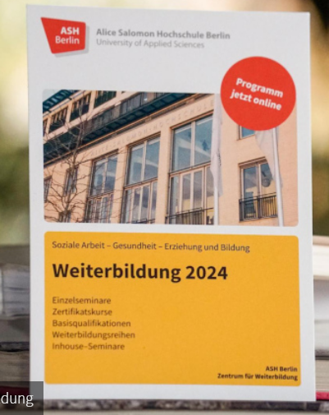](https://www.ash-berlin.eu/weiterbildung/zentrum-fuer-weiterbildung/programm/) for 2025 provide the perfect opportunity to return to the university.

We warmly invite all alumni with a qualifying degree in the SAGE sector to explore our diverse offerings and find inspiration. The program is now available for reading, downloading, and sharing!

For 2025, we are introducing a multiprofessional certification course in Palliative Care, certification courses in human rights-based social work with refugees, and project management in the context of social engagement. These Bachelor- and Master-level courses are led by experienced university faculty.

New to the program is the basic qualification "GAMMA (Health, Mindfulness, and Compassion in Human-Oriented Work)." In addition, we offer a variety of exciting one- to three-day seminars on topics such as social work, childhood education, racism, audism, and more.

We look forward to welcoming you as participants!

**10. Alumni Portraits**

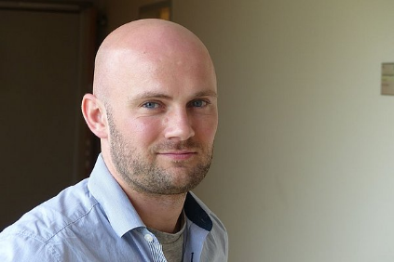Each year, many alumni graduate from ASH Berlin. In which fields do they work after completing their studies? What career paths do they follow, and in which roles do they influence society and contribute to its development?

In each newsletter, we present one of our alumni. Today: [**Michael Brantzko**](https://alice.ash-berlin.eu/seitenwechsel/durch-geoeffnete-tueren-gehen/), graduate of the Health and Nursing Management B.A. and Management and Quality Development in Healthcare M.A. programs.

Our alumni portraits are regularly published on [our website](https://www.ash-berlin.eu/hochschule/vernetzung/alumni-netzwerk/) and in *Alice*, the ASH Berlin university magazine.

**11. Press and Newsroom**

The ASH Berlin magazine is now only available [online](https://alice.ash-berlin.eu/), with articles updated regularly.

You can also subscribe to the ASH Berlin Newsletter, which is published regularly and filled with the latest information about university life.

Please notice the following internet link:

<https://www.ash-berlin.eu/hochschule/presse-und-newsroom/newsletter/>

Enjoy reading it.

**12. Alumni of ASH Berlin on LinkedIn**

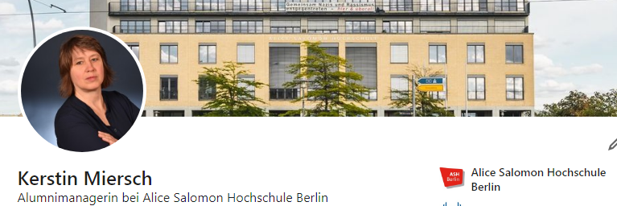

ASH Berlin has a LinkedIn chat for alumni, which we recommend as a communication space: [Kerstin Miersch’s LinkedIn](https://www.linkedin.com/in/kerstin-miersch-9105ab261/).

Additionally, ASH Berlin has a LinkedIn page: [ASH Berlin LinkedIn Page](https://www.linkedin.com/school/alice-salomon-hochschule-berlin/).

On this page, you will find a "Alumni" section where all LinkedIn users who studied at ASH Berlin are connected: [LinkedIn Alumni Section](https://www.linkedin.com/school/alice-salomon-hochschule-berlin/people/).

You will also find job offers from the university on LinkedIn: [ASH Job Listings](https://www.linkedin.com/jobs/alice-salomon-hochschule-berlin-jobs-worldwide).

Job offers published through the ASH Berlin Job Teaser platform can be found [here](https://ash-berlin.jobteaser.com/).

**13. We Say THANK YOU**

* **StudyCheck**



Would you like to share your experiences from your studies and help prospective students make their decisions? Leave a review for your program at [StudyCheck](https://www.studycheck.de/bewerten).

**14. Your Contact Information**

To stay in touch with you, we kindly ask you to update your contact information if it changes, especially your email address. 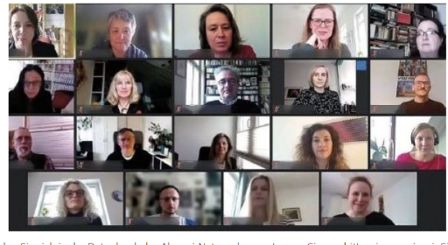Please let us know about any updates. Thank you.

With warm regards and stay connected,

Kerstin Miersch - Alumni Management

Prof. Dr. Gesine Bär – Vice Rector for Research, Cooperation, and Continuing Education  
Elisabeth Hanske – Career Service, Doctoral Support, Germany Scholarship

In case of any disputes regarding these texts, the German version shall prevail.